Lesson 11

Setting up Jenkins Pipeline Job from Git

Objective: To set up a Jenkins pipeline job from Git version control system to enable automated CI for building, testing, and potentially deploying software upon code changes

Tools required: Jenkins, Git and Linux

Prerequisites: None

Steps to be followed:
- Create a Git repository
- Push the pipeline script into the Git repository
- Create a pipeline script-based freestyle job

Step 1: Create a Git repository

Note: If you do not have a GitHub account, visit the official website at https://github.com/signup and create a new account
- Open the browser in your lab, go to github.com, and Sign in to your account
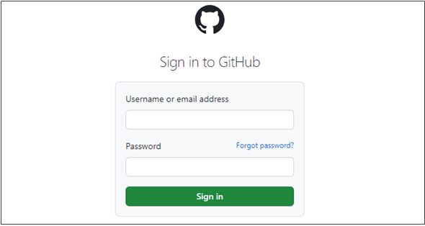

- Click on New as shown in the screenshot below:
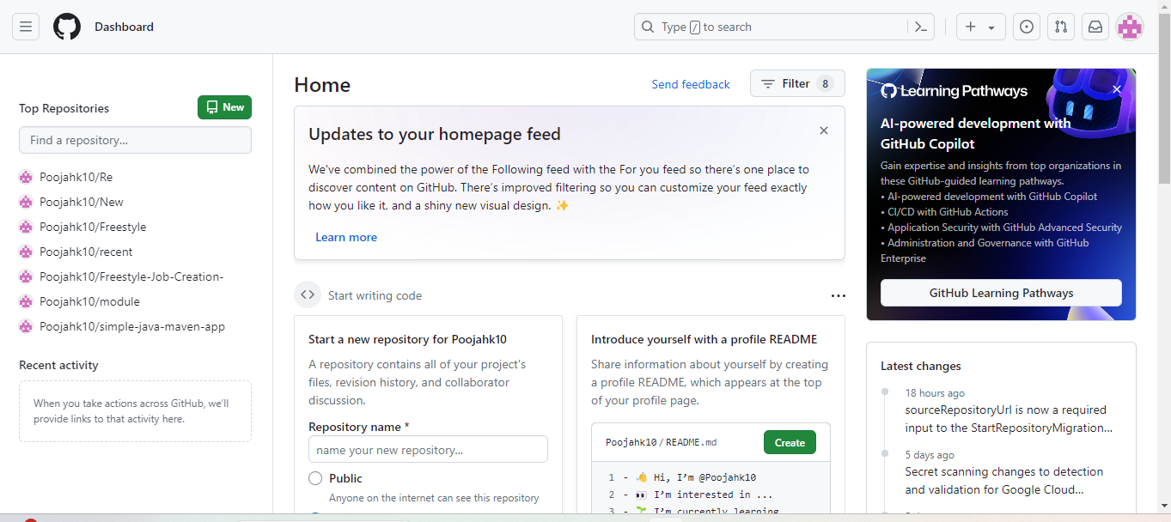

- Enter a desired name for your repository and choose Public as shown in the screenshot below:
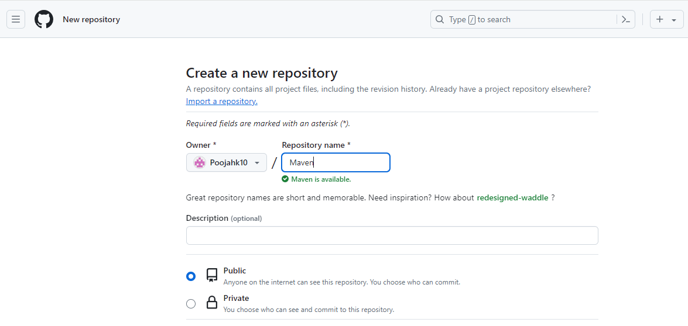

- Click on Add a README file and then click on Create repository as shown in the screenshot below:

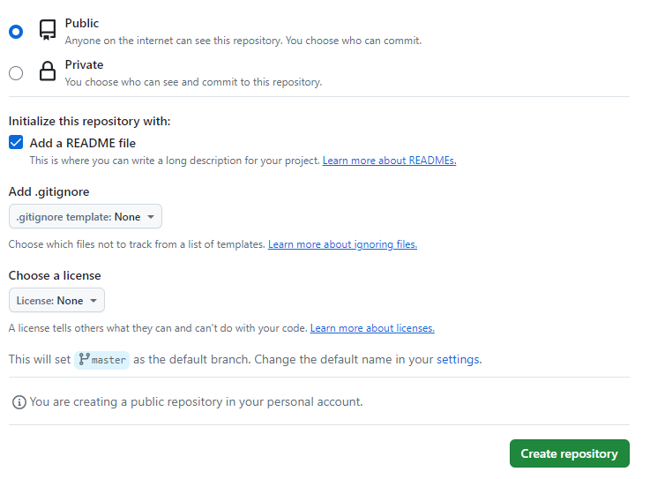

- Click on Code as shown in the screenshot below:
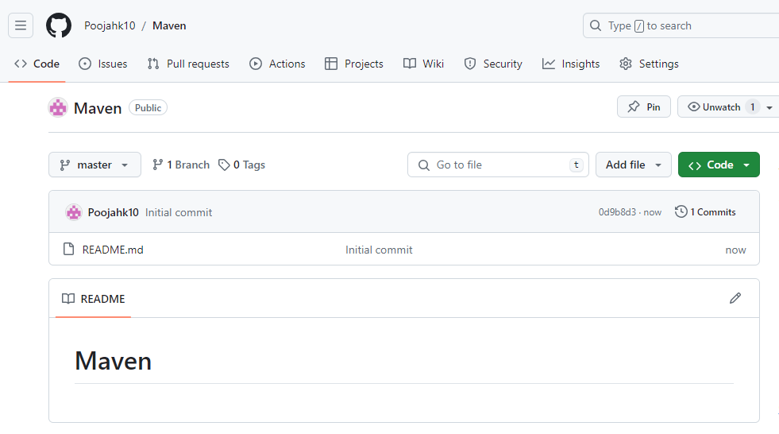

- Copy the repository URL as shown in the screenshot below:

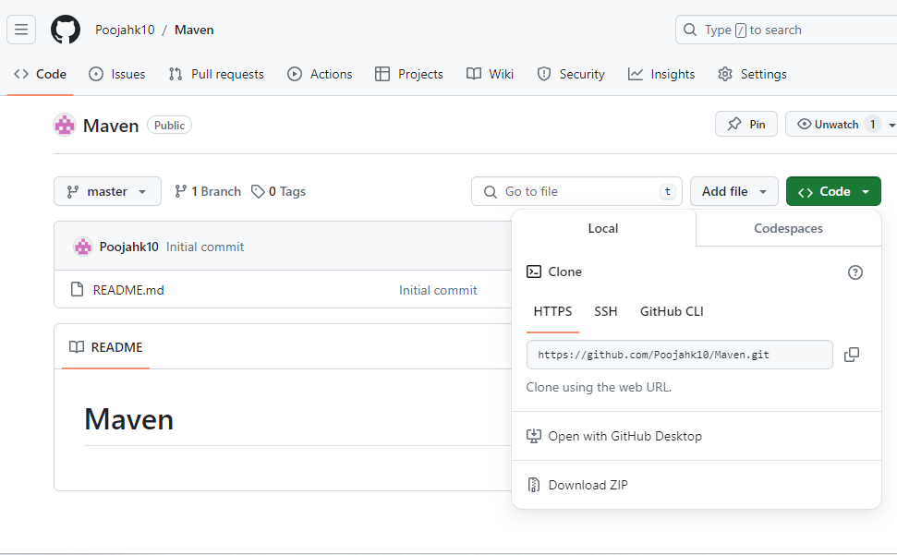
Step 2: Push the pipeline script into the Git repository
- Open the Linux terminal in your lab and clone the repository using the below command:
git clone RepositoryURL
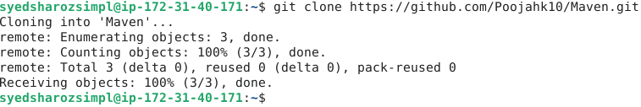
- Navigate inside the repository that you had created using the below command:
cd RepositoryName
- Initialize the Git using the below command:
git init
- Create a file using the below command: (use vs code)
Jenkinsfile
- Paste the below pipeline script inside the file as shown in the screenshot below:
pipeline
{
agent any
tools
{
maven 'MAVEN_HOME'
}
stages
{
stage('Welcome Stage')
{
steps
{
echo 'Welcome to Pipeline'
}
}

stage('Clean Stage')
{
steps
{
bat 'mvn clean'
}
}
stage('Build Stage')
{
steps
{
bat 'mvn install'
}
}
stage('Build Success')
{
steps
{
echo 'Build Success'
}
}

stage('Final Success')
{
steps
{
echo 'Final Success'
}
}
}
}
Note: Ensure you provide your Git repository URL on line7, save, and exit the page by clicking on ctrl+S to save and ctrl+X to exit

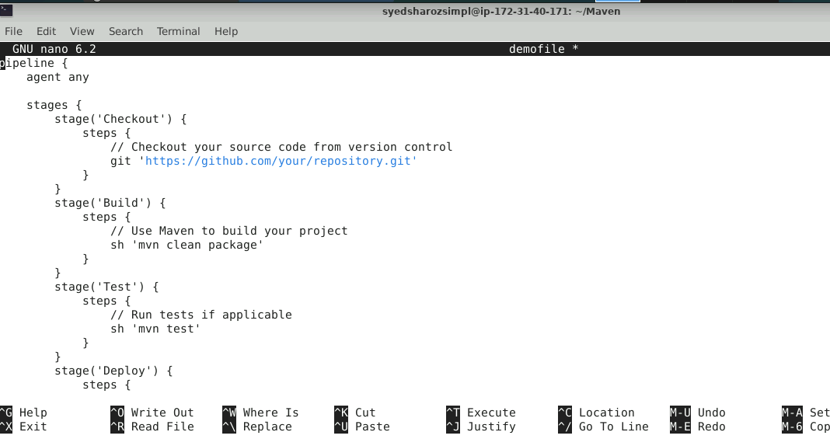
- Stage and commit the changes using the below commands:
git add .
git commit -m “initial commit”
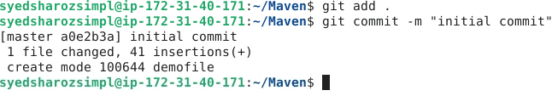

- Push the file to the Git repository using the below command:
git push
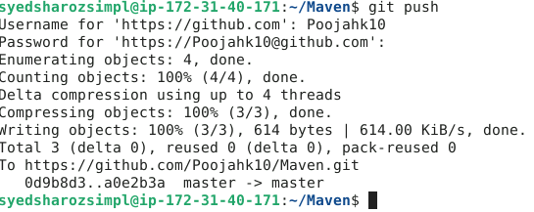
- Navigate to your Git repository to check for the file that is pushed as shown in the screenshot below:
